CAPACITY BUILDING

PREAMBLE



Food Safety and Quality Management is rapidly gaining importance both at national as well as international levels due to various reasons viz implementation of FSS Act 2006, globalization of food trade, harmonization of national standards with CODEX, legal changes at national and international levels etc. The Food Safety and Standards Act passed in the Parliament in 2006 came into force from 5th August

2011. To implement the Act, there is a need for human resources at

various levels involving different stakeholders in the food chain from farm to fork which includes Regulators (Designated Officers, Adjudicating Officers and Food Safety Officers), Food Auditors, Food Analysts (Microbiology/ Chemical), Food Handlers (Manufacturer, Wholesaler Retailer etc.). The Act calls for an enabling environment for its successful implementation and movement towards a science based approach to assure safety and the quality of food. Development of trained human resource in food safety sector is essential for speedy implementation of Act.

Food Safety & Standard Authority of India has designed a Training Policy for different levels of Food Safety Regulatory Officials. The Training Policy of the Regulatory Staff was discussed by 17th Central Advisory Committee and was approved by Food Authority in its 21st Authority Meeting. This Manual is a guiding document towards the Training Policy, Curriculum as well as all other Training related other information.

INTRODUCTION FOR TRAINEE



Food Safety & Standard Authority of India has designed the Training Policy of Regulatory Officials as an integral element of its Food Control System. This Chapter gives a brief outline of the scope of learning through Capacity Building programme for Food Safety Regulators.

Food Safety Officer:

The FSO is the representative of the Food Authority who interacts directly and closely with the FBO on a regular basis. Therefore, he can play a crucial role not only in implementation of the provisions of the FSS Act,2006 but also act as a guide to FBOs in complying with the provisions of the FSS Act, rules and regulations made there under. The role of FBO in ensuring safe and wholesome food for human consumption cannot therefore be overstated. Considering the importance of role of FSO, the training has been designed in an integrated manner and Training Material has been developed with great care. During the 40-day long Training Programme, FSOs will learn about Concepts of Food Safety, new provisions of the Acts & Rules, Standards and new approaches to Monitoring of Food Safety. Check Lists which will help them in day to day activity will be a crucial element of the Training Programme.

Designated Officer:

As per Section 36, the Commissioner, in turn, appoints the Designated Officer, who must not be below the rank of a Sub-Divisional Officer, to be in-charge of food safety administration in a specified area. Besides, Designated Officer is the Licensing Authority who can issue or cancel the License of FBO. Thus, the training of Designated Officer is imperative.

The Programme will provide the Designated Officer with training inputs on the FLRS system, Surveillance procedure, Sampling methodology, Adjudication and such relevant topics which will empower them to perform effectively in their field duties.

Adjudicating Officer:

As per Section 68 of the FSS Act, the Adjudicating Officer is required to be not below the rank of Additional District Magistrate. The state government is required to notify an officer not below the rank of ADM for the district where the alleged offence was committed. AO is considered to be a civil court for the purposes of the Act. It has the power to punish for contempt or obstruction of its proceedings. Thus, Adjudicating Officer plays a crucial role in enforcement of the Law. The Training Programme will help AOs to get a thorough knowledge and ready reference on Food Safety & Standards Act, Rules & Regulations along with the procedure of Adjudication in the light of relevant clauses of all related legislation.

Food Safety Commissioner:

The Commissioner of Food Safety shall be responsible for the efficient and effective implementation of the FSS Act in the State or UT as the case may be. As per Section 10(5) of the FSS Act, the Chief Executive Officer (CEO) of the FSSAI is entrusted to exercise the powers of the Commissioner of Food Safety while dealing with matters relating to food safety. It reflects the domain of Food Safety Commissioner in maintaining food safety. FSSAI has designed a one-day workshop for sensitization and brief understanding of Role of Food Safety Commissioner in the light of evolving need & importance of food safety.

TRAINING POLICY

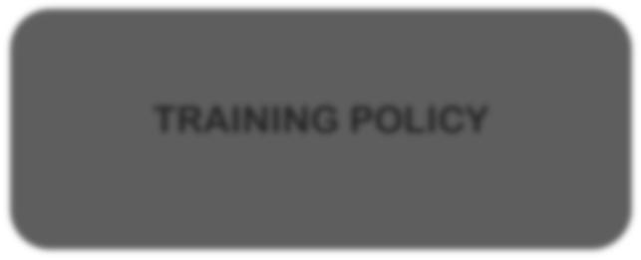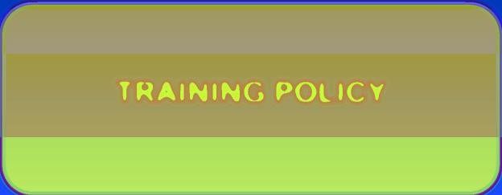

Clause 2.1.2 and 2.1.3 of Chapter 2, Food Safety & Standards Rules

2011 emphasizes the need of training for Designated Officers and Food Safety Officers. The Training Policy has been approved by 21st Meeting of the Food Authority.

This New Training Policy that has envisaged a training framework as under:

INDUCTION TRAINING

REFRESHER TRAINING

Induction Training has been structured for newly recruited officers. The

structure of the Training for newly recruited FSOs is as under:

INDUCTION TRAINING FOR FSO



Foundation Phase

1 Mode of Training: On- Line

Duration: 5 Days

Learning Phase

2 Mode: Class Room

Duration: 12 Days

Application Phase

3 Mode: On- Job

Duration: 23 Days

FOUNDATION PHASE



Foundation Phase of Induction Training contains six Units. Objective of this Phase is to give the newly recruited officer, an understanding on food safety concepts & issues, evolution of Food Safety Act, Global and Indian perspectives, the need and importance of food safety, basis of Food Production Process. Compliance of Food Law by the Food Business Operators as well as its enforcement would also be highlighted. The Foundation phase will be delivered to the Trainee through an e learning course, available on our website. This is a self-learning module with power points by domain experts. This material can be used by the Trainee even after finishing the Foundation Phase as a guiding document. Trainee will need 30 minutes on average to study each Module and has to finish the whole Foundation Phase within 5 days. After completion of each Unit, there will be a mandatory On-line Assessment. Trainee has to undergone these Assessments successfully to be eligible for the Learning Phase (Class-Room Programme).

STRUCTURE OF FOUNDATION PHASE MAXIMUM DURATION -5 DAYS MODE OF TRAINING : ONLINE

|  |  |  |  |
| --- | --- | --- | --- |
| **UNIT NUMBER** | **UNIT NAME** | **NUMBER OF MODULE** | **DURATION OF UNIT** |
| **Unit 1** | Evolution of Food Safety | 3 | 90 min |
| **Unit 2** | Basic of Food Composition | 3 | 90 min |
| **Unit 3** | Food Categories | 2 | 60 min |
| **Unit 4** | Food Production Practices | 4 | 120 min |
| **Unit 5** | Concept of Food  Standards | 5 | 150 min |
| **Unit 6** | Major Contaminants | 5 | 150 min |

LEARNING PHASE



Second Phase of Induction Training is the Learning Phase. Trainee will receive training in the class room directly from expert faculties. Learning outcome of this phase is aiming at the enhancement of proficiency level of the newly recruited staff. The curriculum of this level is mostly based on topics useful for the field level regulatory staff such as understanding of the Administrative Structure, job description, inspection procedure, surveillance procedure, adjudication etc. This phase of the Induction Training will be held at Training Institutes nominated by the State as well as recognized by the FSSAI for the purpose of Training of Regulatory Staff. Trained faculties will provide training to the newly recruited officials. Total duration of the training is of twelve days. After successful completion of class room training, trainee will be allowed to move forward to the next phase i.e Application (on-job) Phase. Trainee will receive a guidebook along with required Check-Lists for inspection, Forms and other documents both in soft and hard copy. Class Room session will have twelve Units to study. Each Unit again is divided into Modules. Cumulative duration of all the Modules will be twelve days. This document will guide the States with a ready schedule or session plan for the class room training. This plan will also be available on the website which will enable the States to get their own training schedule by entering the information regarding the proposed training date and time. The list of faculties for specified subjects and regions of their availability can also be accessed by the States from this website, thus enabling States to plan their training schedules as per their requirement.

STRUCTURE OF LEARNING PHASE MAXIMUM DURATION -12 DAYS MODE OF TRAINING: CLASS ROOM

DAY



FORE NOON SESSION

TOTAL DURATION 4 HOURS LUNCH

AFTER NOON SESSION TOTAL DURATION 4 HOURS

Learning Phase will be held in the Class Room. Each day will have two Sessions- Forenoon & Afternoon Sessions of four hours each. Both the Sessions will have a lunch break in between. Further, each session will have two classes. Each Class will have tea break in between.

CURRICULUM OF LEARNING PHASE

|  |  |  |
| --- | --- | --- |
| **DAY** | **SESSION** | **UNIT** |
| **1** | Forenoon | Introduction [Unit 1] |
| Afternoon | Administration of Act at Central Level [Unit 2] |
| **2** | Forenoon | Administration of Act at State & UT [Unit 2] |
| Afternoon | Duties & Responsibilities [Unit 3] |
| **3** | Forenoon | Role of Participants (FSO) [Unit 3] |
| Afternoon |
| **4** | Forenoon | Licensing & Registration [Unit 4] |
| Afternoon |
| **5** | Forenoon | Packaging-Labelling[Unit 5] |
| Afternoon | Regulatory Compliance [Unit 6] |
| **6** | Forenoon |
| Afternoon |
| **7** | Forenoon |
| Afternoon | Food Safety Management System [Unit 7] |
| **8** | Forenoon | Surveillance, Monitoring & Evaluation [Unit 8] |
| Afternoon |
| **9** | Forenoon |
| Afternoon |
| **10** | Forenoon | Sampling & Laboratories [Unit 9] |
| Afternoon | Export, Import & Quarantine [Unit 10] |
| **11** | Forenoon | Adjudication [Unit 11] |
| Afternoon |
| **12** | Session End | FSSAI Imitative, Feedback, Assessment [Unit 12] |

APPLICATION PHASE



Third phase of Induction Training is Application Phase, where trainees will be sent to the field for practical experience. The aim of this phase is the assimilation of all the knowledge gathered by the trainee during two previous phases. Total duration of this phase is of 23 working days. During this phase, the trainee will be given specific tasks. After finishing each task, trainee has to prepare a report and has to submit the same to his or her appointing authority with a copy to the Food Authority. At the end of the On-Job Application Phase, concluding Session of the total Induction Programme will be held. In that session, debriefing will be held where trainee will present specific projects that they have been allotted during training. The projects will be evaluated at the time of presentation

and certification to the trainee will follow subsequently.

STRUCTURE OF APPLICATION PHASE MAXIMUM DURATION -23 DAYS MODE OF TRAINING: ON JOB

Attachment to Industry for practical understanding of the process, GHP-GMP plan

1 Total Duration: 6 Days

Visit to 4 High Risk Sectors & 2 Low Risk

Sectors

Total Duration: 3 Days

2



Attached to Food Safety Officer/Designated

Officer

3 Total Duration: 3 Days

Attached to Laboratories for understanding

Lab Activity

Attached to Designated Officer & Debriefing

4 Total Duration: 3 Days

5 Total Duration: 5 Days

Assessment, Debriefing & Certification

6 Total Duration: 3 Days

Structure of training of Designated Officer is as under:

TRAINING



FOR DESIGNATED OFFICER

DAY

Evolution of Need of Food Safety,

1 Administrative Structure & Duties

2 Understanding of Food Safety, Licensing & Registration

3 Packaging & Labeling, Regulatory



Compliance, FSMS

Surveillance, Monitoring & Risk

4 Analysis, Sampling, Adjudication

Debriefing & Certification

5

TRAINING



FOR ADJUDICATING OFFICER

TRAINING

FOR FOOD SAFETY COMMISSIONER



60 MIN

Concept of Food Safety

Concept of Food Safety 60 MIN

90 MIN

90 MIN

60 MIN

120 MIN

Food Control System

Understanding of food safety

Adjudication & Penalties

Regulatory Provision of other Act in the country

Evolution of Food Safety in World & India

Understanding of Food

Safety, FSMS, Food Frauds

Centre & State

Administration

Enforcement of Act

90 MIN

90 MIN

60 MIN

120 MIN

60 MIN

Case Studies

Adjudication

60 MIN

REFRESHER TRAINING



Refresher Training has been structured for existing Food Safety Officer or Designated Officer or Technical Officers. While Induction Training is mandatory for all newly recruited Food Safety Officer, Annual Refresher Training is mandatory for all officers. Two types of Refresher Training have been designed which are Routine Refresher & Need Based Training. The aim of the Refresher Training is to refresh the knowledge and approach

of the Officers and to percolate additional information to them.

ROUTINE REFRESHER TRAINING FOR FSO



DAY



NEED BASED REFRESHER TRAINING FOR FSO /DO/TO

Evolution of Need of Food Safety, FSS 1

Act, Administrative Structure & Duties

Procedure for Regulatory

Compliance 2

FSMS, Development of Sector specific 3

GHP-GMP compliance

Introduction to any Subject

& Need of its evaluation

Understanding of that

Subject

Hands on experience as required

Surveillance, Monitoring & Risk Analysis,

Sampling & Laboratories, Packaging & 4

Labelling & Documentation

Online Licensing & Registration 5

Adjudication 6



Current FSSAI Initiative & Interactive

Session, Debriefing & Certification 7



Need based Refresher Training will be subject oriented. Any specific subject, which will be useful for the trainee in enforcement of the Act, will be provided

in three-day package. Any trainee, either FSO or DO or TO can enroll for this type of Refresher Training to get knowledge of any particular subject of his or her choice. Knowledge on new initiatives of FSSAI, new projects, standards, websites will be imparted through the need based training programme.

TRAINING



FOR FOOD SAFETY COMMISSONER

FSSAI have planned for one-day workshop for providing training to Food Safety Commissioner or Joint Food Safety Commissioner. Aim of this workshop is to give a brief outline on need of food safety, Food Safety &

Standard Act and other major administrative role for enforcement of the Act.

TRAINING



FOR FOOD SAFETY COMMISSONER

Training Programme for Adjudicating Officers are designed specially to meet up the requirement of knowledge on rules, regulation on food safety, relevant provisions in other acts. Case studies, judgment also will be provided for

ready reference.

OTHER TRAINING PROGRAMME



|  |  |  |
| --- | --- | --- |
| **Training Name** | **Duration** | **Mode of Delivery** |
| **Adjudicating Officer’s Program** | **1 Day** | **On-Line or Class**  **Room** |
| **Technical Officer’s Program** | **1-3 Days** | **Classroom** |
| **Train the Trainer’s Program** | **7 Days** | **Classroom** |
| **Training for Middle Management Group** | **3 Days** | **Classroom** |
| **Training for Senior Management Group** | **3 Days** | **Classroom** |



###### ASSESSMENT POLICY

Each Training will be followed by an assessment. SOP for assessment if as follows. This is also an indicating one. State may change according to their need and as per the type of training also. Here, the prescribed preformat of assessment has been provided for FSO Training.

The assessment will be out of 100 marks.

The mark split – up of the assessment is as follows :

Basis understanding of the subject – 20 marks

It can be evaluated by compiling feedback form for each session.

Field Training – 10 marks

In case of FSO Training, Designated Officer concerned may be entrusted to make an assessment on the basis of the diary prepared by each trainee to keep a record on the same.

Attendance – 10 marks

The valuation may be done by the senior officials like Commissioner of Food Safety after viewing the PPTs and presentation of the Trainees using the same.

Test Paper – 50 marks

There will be objective assessment in the form of 50 Multiple Choice Questions on various scientific aspects of Food Safety including analysis and on the legal processes involved such as regulatory and enforcement activities.

**Sample Assessment Form**

|  |  |  |  |
| --- | --- | --- | --- |
| Assessment Form | | | |
| Name of candidate | | | |
| Sl. No. | Particulars | Marks awarded | Max. Marks |
| 1. | Test Paper |  | 50 |
| 2. | PPT Presentation |  | 25 |
| 3. | Field Training/on job training |  | 10 |
| 4. | Understanding of the subject |  | 10 |
| 5. | Attendance |  | 5 |
|  | Total |  | 100 |

**BUDGET**

Rs. 1000/- per participant will be provided for training materials and stationery associated with the training during the classroom module.

TRAINING ECOSYSTEM

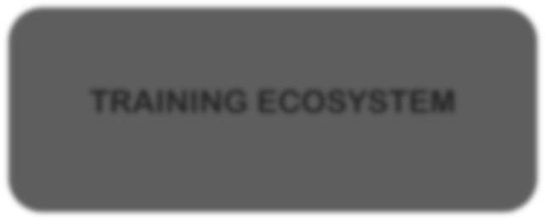

FSSAI has structured a detailed Training Policy covering each layer of its administrative force so that knowledge can be disseminated every segment evenly and in a routine manner. To achieve the purpose, FSSAI also has developed a robust ecosystem up on which the Training Policy can easily be administered.

Apart from Trainee, the other factors of the Regulatory Training Ecosystem are as follows:

•FSSAI empanelled subject matter experts for redesigning the existing Training Curriculum and Content.

•Content developed by experts has been duly vetted by the respective divisions of FSSAI



•At the final stage, all the content has been vetted by a Vetting Committee of senior domain experts established by FSSAI

•FSSAI has empanelled Trainers by inviting Expression of Interests and subsequently selection of eligible persons.

•The trainers are from academia, industry as well as from Food Safety Regulatory Officials. The intention behind this is to leverage all the resources on food safety in a single platform.



•Trainers have been trained by Mater Trainers who are in turn guided by the Vetting

Committee of FSSAI

•As per Training Policy, training will be imparted through website and also through classroom modules. Training Institutes have been identified in each State.



•For recognition of Training Institute, respective States have nominated an Institute within the State or have proposed to utilize the Institutes of neighboring States

•FSSAI has visited to the Institutes jointly with the States and has recognized them.



•Budget has been divided into four components namely Training Partner's Cost, Trainer's honorarium & accommodation, Training Material & working lunch and tea for participants.

•State Government will bear TA/DA to the participants as per their entitlement.

•State Government will look after local picks & drop arrangement for the participants, faculties & Nodal Officers.

TRAINING CONTENT



FSSAI has developed study material with the Subject Matter Experts in the respective fields. Content of the material has been vetted by an expert committee. The content has been designed with graphical presentations, animations and other visual aids which have made the study material more user friendly and crisp.

*Study Material*

At the initial stage of Induction Training, newly recruited Food Safety Officer will be provided on line study material in the audio-visual format. Power point presentations delivered by the Subject Matter Expert accompanied by visual graphics. In addition to that, trainee will receive text content in

downloadable form along with useful links for in depth study.

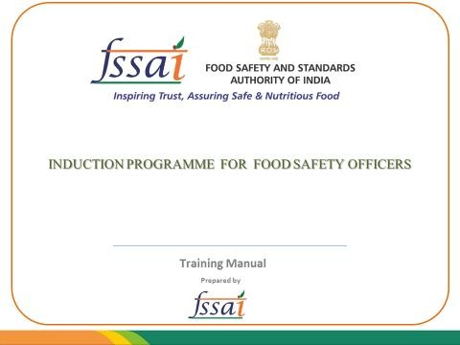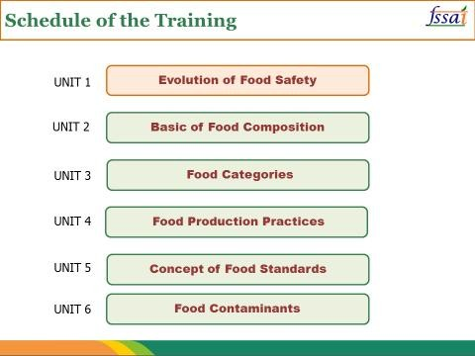

Pictures are the opening slides of the foundation course. Each unit will be hyperlinked to the respective presentations. Each presentation will have a dialogue box where trainee can ask questions which will be

replied to by the experts.

DESIGNATED OFFICERS’

GUIDEBOOK

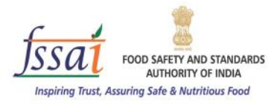

FSO GUIDE

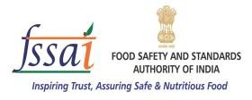

**Training Manual**

**Prepared by**

**Training Manual**

**Prepared by**

During classroom session of Designated Officers or Food Safety Officers, trainees will be provided with the Designated Officer’s Guidebook and FSO Guide. In both guidebooks, apart from the relevant subjects, checklists & prescribed formats, case studies examples etc will be available. In each case, Trainer’s Guide will also be provided. Trainer’s Guide will be equipped with Case Studies, sample presentation, methodology of training, sample activities which will be useful for trainer while providing training.

*Subject*

The identification and selection of subjects which has to be delivered during training of the Regulatory Staff has been done to ensure competency based training.

In Induction Training of FSO, the subjects of Foundation Phase are basic in & introductory in nature. Subjects of learning phase are more practical knowledge oriented. Tasks given to the FSO, during on job training is a practice session.

For Training of DO, the subjects are based on enhancing competency in performing the assigned job.

List of topic to be covered during Induction Training for FSO : Foundation

|  |  |  |  |
| --- | --- | --- | --- |
| **Unit** | **Unit name** | **Module** | **Speaker** |
| 1 | Evolution of  Food Safety | Concept of Food  Safety | Dr M K Salooja, Director, School  of Agricultural Science IGNOU |
| Global Evolution  WTO | Mr Sanjay Dave, Ex Advisor FSSAI |
| Global Evolution-  CODEX | Mr Sanjay Dave, Ex Advisor FSSAI |
| CODEX India | Miss Sukhmani Singh, Technical  Officer, CODEX, FSSAI |
| Evolution of Food  Safety in India | Mr P Kartikeyan, Assistant  Director, FSSAI |
| 2 | Basic of Food  Composition | Understanding  Food | Dr Joseph Lewis, Expert FSSAI |
| Macro & Micro  Nutrients | Dr Eram Rao, Professor, Delhi  University |
| Food Fortification | Dr Eram Rao, Professor, Delhi  University |
| 3 | Food  Categories | Understanding of  Food Categories | Dr Prabodh Halde, President  AFSTI (Mumbai Chapter) |
| Food Category  System in FSSR | Dr Prabodh Halde, President  AFSTI (Mumbai Chapter) |
| 4 | Food Production Practices | Food Preservation | Ms Aditi Bhatnagar, Technical  Officer, FSSAI |
| Organic Food | Dr PVSM Gouri, |
| GM Food | Ms Aditi Bhatnagar, Technical  Officer, FSSAI |
| Irradiated Food | Prof A K Kohli, |
| 5 | Concept of Food Standards | Understanding of  Food Safety | Mr P Kartikeyan, Assistant  Director, FSSAI |
| Food Standards | Mr Sanjay Dave, Ex Advisor FSSAI |
| Food Safety  Management  System | Dr Prabodh Halde, President  AFSTI (Mumbai Chapter) |
| Traceability &  Food Recall | Dr Prabodh Halde, President  AFSTI (Mumbai Chapter) |
| Food Frauds:  Adulteration | K M Nath, Expert FSSAI |
| 6 | Food  Contaminant | Pesticides | Dr K Kanungo, Chairperson,  Scientific Panel on Pesticides & Antibiotic Residues, FSSAI |

|  |  |  |  |
| --- | --- | --- | --- |
| 7 | Food  Contaminant | Antibiotic | Dr Ranum Dabas, Scientist, FSSAI |
| Heavy Metals | Dr Nilesh Amritkar, MD,  Envirocare Labs |
| Mycotoxins | Dr Nilesh Amritkar, MD  Envirocare Labs |

List of topic to be covered during Induction Training for FSO : Classroom

|  |  |  |
| --- | --- | --- |
| **Unit** | **Unit name** | **Module** |
| **1** | Introduction | Evolution of Food Safety –Global & Indian Context |
|  |  | Concept of National Food Control System |
|  |  | Food Safety & Standards Act |
| **2** | Administration of Act | Food Safety & Standard Authority of India |
|  |  | Enforcement role at State & Union Territories |
| **3** | Duties & Responsibilities | Role of Food Safety Commissioner |
|  |  | Role of Designated Officer |
|  |  | Role of Food Safety Officer |
|  |  | Role of FBO & Consumer |
| **4** | Licensing & Registration | Regulation on Licensing & Registration |
|  |  | FLRS |
| **5** | Packaging & Labelling | Packaging |
|  |  | Labelling –compliance |
| **6** | Regulatory Compliance  & Verification | GHP-GMP Requirement |
|  |  | Sector Specific Inspection (Milk & Dairy, Fat & Oil,  Processed Fruit & Vegetable, Water & flavoured drink, Slaughter House, Meat & Poultry, Fish & Fishery, Special Foods, Bakery Product, RTE |
| **7** | Food Safety  Management System | GHP-GMP |
|  |  | HACCP |
| **8** | Surveillance, Monitoring  & Evaluation | Surveillance |
|  |  | Monitoring & Evaluation |
|  |  | Risk Analysis |
| **9** | Sampling & Laboratories | Food Laboratories |
|  |  | Procedure of Sampling & Documentation |
| **10** | Food Export, Import &  Quarantine | Import & Quarantine |

|  |  |  |
| --- | --- | --- |
|  |  | Export & Export Promotional Bodies |
| **11** | Adjudication | FSS Act in relation to other legal Provisions |
|  |  | Procedure & Documentation |
| **12** | FSSAI Initiative | 10 [@10](mailto:@10) initiative & other projects |

List of topic to be covered during Training for DO: Classroom

|  |  |  |
| --- | --- | --- |
| **Unit** | **Unit name** | **Module** |
| **1** | Introduction | Evolution of need of Food Safety –Global & Indian  Context |
| Shift in perspective of law |
| Food Safety & Standards Act |
| **2** | Administration of Act | National Food Control System |
| Enforcement role at State & Union Territories |
| **3** | Duties & Responsibilities | Role of Food Safety Commissioner |
| Role of Designated Officer |
| Role of Food Safety Officer |
| Role of FBO & Consumer |
| **4** | Licensing & Registration | Regulation on Licensing & Registration |
| FLRS |
| **5** | Packaging & Labelling | Packaging |
| Labelling –compliance |
| **6** | Regulatory Compliance  & Verification | GHP-GMP Requirement |
| Sector Specific Inspection (Milk & Dairy, Fat & Oil,  Processed Fruit & Vegetable, Water & flavoured drink, Slaughter House, Meat & Poultry, Fish & Fishery, Special Foods, Bakery Product, RTE |
| **7** | Food Safety  Management System | GHP-GMP |
| HACCP |
| **8** | Surveillance, Monitoring  & Evaluation | Surveillance |
| Monitoring & Evaluation |
| Risk Analysis |
| **9** | Sampling & Laboratories | Food Laboratories |
| Procedure of Sampling & Documentation |
| **11** |  | FSS Act in relation to other legal Provisions |

|  |  |  |
| --- | --- | --- |
|  | Adjudication | Procedure & Documentation |
| **12** | FSSAI Initiative | 10 [@10](mailto:@10) initiative & other projects |

List of topic to be covered for Training of Adjudicating Officer: On-Line or Class room

|  |  |  |
| --- | --- | --- |
| **Uni**  **t** | **Unit name** | **Module** |
| **1** | Introduction : Concept of  Food Safety | Evolution of need of Food Safety –Global & Indian  Context |
| Food Safety & Standards Act |
| **2** | Administration of Act: National Food Control System | National Food Control System |
| Enforcement role at State & Union Territories |
| **3** | National Food Control System :Duties & Responsibilities | Role of Adjudicating Officer |
| Role of FBO & Consumer |
| **4** | Understanding of Food  Safety | Concept of Food Safety |
| GHP-GMP Requirement by the Food Sectors |
| Food Hazards |
| Food Adulteration |
| **6** | Adjudication & Penalties, Regulatory Provisions in other Act and Case Studies | Purpose of Adjudication |
| Adjudication within FSS Act |
| Food Safety Appellate Tribunal |
| Knowledge of other law of the land |
| BIS Consumer Protection Act 1986 |
| Legal Metrology Act 2009 |
| Cases under PFA |
| Judgments under FSS Act |
| Procedure of Sampling & Documentation |
| FSS Act in relation to other legal Provisions |
| Procedure & Documentation |

TRAINING INSTITUTE

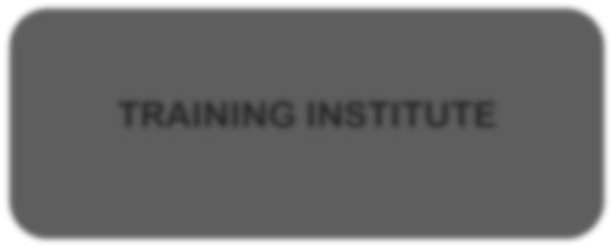

FSSAI has recognized Training Institutes from the States for conducting the Training of Food Safety Regulatory Staff. States have nominated the Institutes. Joint visits were made by FSSAI and the respective State representatives and on finding them suitable for conducting training, the institutes have been duly recognized for this purpose. Following table shows the State wise list of institutes for the Training.

|  |  |  |  |
| --- | --- | --- | --- |
| **Sl**  **No** | **Training Institute** | **Session Capacity at a time** | **States Attached** |
| **1** | RFPTC, Jaipur First Floor, Room No.  28, Heerabagh, Jawahar Nagar, Jaipur  – 302004 | 110 | Rajasthan |
| **2** | Chhattisgarh Academy of Administration,Raipur Chhattisgarh Academy of Administration, Nimora, Raipur - 493661 | 160 | Chattishgarh |
| **3** | Deen Dayal Upadhyaya State Institute of Rural Development, Lucknow | 350 | Uttarpradesh |
| **4** | Assam Administrative staff Training College, Jawahar Nagar, P.O. Khanapura, Guwahati-781022 | 100 | Assam, Manipur, Meghalaya, Arunachal Pradesh, Nagaland, Sikkim, Tripura, Mizoram |
| **5** | Jawaharlal Nehru Technological  University Kakinada, Andhra Pradesh |  | Andhra Pradesh, Telengana, Andaman & Nicobar |
| **6** | Institute of Research & Development, Gujarat forensic Sciences University, Sector 9, Gandhi Nagar, Gujarat | 800 | Gujarat |
| **7** | Administrative Training Institute, P & AR Department, FC Block Sector – III,  Kolkata - 700106 |  | West Bengal |

|  |  |  |  |
| --- | --- | --- | --- |
| **Sl No** | **Training Institute** | **Session**  **Capacity** | **States Attached** |
| **8** | All India Institute of Local Self Government, Barfiwala Bhawan, Near Bhawan’s College, Khanpur, Ahmedabad, Gujarat - 380001 |  | Gujrat, Dadra & Nagar Haveli |
| **9** | National Institute of food Technology Entrepreneurship and Management, Sonepat, Haryana |  | Haryana, Delhi |
| **10** | Institute of Public health Convention Centre, RCH Campus, Namkum, Ranchi, Jharkhand |  | Jharkhand, Bihar |
| **11** | Indian Institute of Public Health, Bangalore State institute of Health and Family Welfare, Magadi Road, Bengaluru  Executive Development Centre, Institute of Hotel Management, SJP Campus, Bengaluru |  | Karnataka, Andman & Nicobar |
| **12** | The Council for Food Research and Development, Under Department of FCS & CS, Government of Kerala (CFRD), Anakuthi, Perinjottakkal P.O., Konni, Pathanamthitta Dist. Kerala Pin-689692 | 300 | Kerala, Lakshwadwip |
| **13** | RCVP Academy, Arera Colony, Shahpura, Bhopal, Madhya Pradesh 462016 |  | Madhya Pradesh |
| **14** | FDA, Opposite RBI, Survey No- 341, BKC, Bandra east, Mumbai, Maharashtra – 400051 | 250 | Maharashtra, Andman & Nicobar |
| **15** | YASHDA, Raj Bhawan Complex, Baner  Road, Pune |  | Maharashtra, Goa , Daman & Diu |
| **16** | Indian Institute of Public Health, 2nd &  3rd Floor, JSS Software Technology Park, E1/1 Infocity Road, Patia, Bhubneshwar, Odisha – 751024 | 150 | Odisha |
| **17** | State Institute of Health & Family Welfare, Near Civil Hospital, Phase 6,Mohali, Punjab |  | Punjab, Chandigarh |
| **18** | Institute of Public Health, Karayanchavadi, Poonamallee, Chennai | 580 | Tamilnadu , Puducherry |
| **19** | Divisional Health & Family Planning Training Centre, 107, Moti Nagar, Haldwani, Distt Nainital - 263139, Uttarakhand | 130 | Uttarakhand, Himachal Pradseh |
| **20** | Institute of Management, Public Administration and Rural Development(Main Campus), M A Road, Srinagar, Kashmir, J & K   Institute of Management, Public Administration and Rural Development (Regional Campus), Sidhra Byepas Jammu, J & K. |  | Jammu & Kashmir |

25 | P a g e



SUBJECT MATTER EXPERT



FSSAI has empanelled subject matter experts who have developed content for training of Regulatory Officials. They are the domain experts from Academia, Industry and the Food Regulatory Sectors.

A four-member Committee also was developed for revising the content of Training Material for Regulatory Staff. The members are Shri Sanjay Dave, Ex Chairman CODEX Alimentarius & Advisor to FSSAI, Shri Salim Veljee, Food Safety Commissioner of Goa, Dr. Geetanjali Sharma, Chief Microbiologist, Central Food Laboratories, Kolkata and Dr. Rubinaa Shaheen, Director, R & RD FSSAI.

Subject matter experts have undergone TOT conducted by FSSAI to maintain uniformity in delivery of training. The subject and region specific list of FSSAI certified trainers are enclosed.

Master Trainers to ensure relevance and quality of training.

A team of Master Trainers have been identified who in turn will provide

training to trainers.

List of Master Trainers

in alphabetical order

**Mr A K Srivastava**

**9968311884**



**Mr Srivastava is Consultant to PAV LAW office, New Delhi & associated with food safety for more than 35 years. He is an expert on Regulations, Administration of FSS Act**

**Ms Chinmayee Deulgaonkar**

**9930109209**

**In food sector for last 12 years & an expert in FSMS, Quality Auditing**

**Mr D Shivakumar**

**08943346181/ 09447891742**

**Mr Shivkumar is Joint Food Safety Commissioner, Kerala. An expert on Enforcement of FSS Act, Surveliiance, Monitoring, Sampling, Adjudication**

**Dr Eram Rao**

**9818881588**

**Dr Rao is Assistant Professor of Delhi University. She has 21 years of teaching experience. She is an expert on Food Science & Nutrition, Food Processing & food fortification.**

**Dr Jasvir Singh**

**9958995804**

**Scientific & regulatory head in Mondelez Inida Food. Expert in packaging labelling, FSMS, Quality Auditing**

**Mr K M Nath**

**9899532067**

**Mr Nath is Ex Joint Director, FSSAI. He is an expert on FSS Act, Enforcement of Act, Labelling**

**Dr M K Salooja**

**9891581750**

**Professor of IGNOU with 15years of teaching experience. He is an expert in food processing, food science & nutrition.**

**Dr Nilesh Amritkar**

**9167232003**



**He is MD, Envircore Lab & Vice President AFSTI. He has 17 years of experience on Food Lab, Risk analysis, Contaminations**

List of Master Trainers

**Dr Prabodh Halde**

**9820278746**



**Dr Halde is associated with food sector for last 25 years. He is President of AFSTI, Mumbai**

**Chapter. He is an expert on FSMS, Surveillance, Regulatory Compliance, Packaging-Labelling**

**Dr Praveen Gangadhar**

**9810108823**

**Dr Gangadhar FSS Act and Rules, Risk assessment and analysis, surveillance, international food laws**

**Mr P K Jaiswal**

**9958286537**

**Ex Director Ministry of Agriculture. He is an experience of 25 years in food safety research &**

**Training.**

**Ms Sahana Chatterjee**

**8800491498**

**Principal Advocate, Amarchand & Managaldas Group. Experience in drafting food safety regulations and regulatory matters**

**Mr Sanjay Indani**

**7666578715**

**Mr Indani is a lead trainer on Food Safety Management System associated with European Union**

**Ms Subhaprada Nishtala**

**7738083991**

**Expert in Quality Assurance, Labelling & Claims, FSMS**

**Mr Sunil Adsule**

**9899998134**

**Director, Scientific & Regulatory Affair, Coca-Cola India Pvt Ltd. Expert in Food Science & Processing, Food regulation, GHP-GMP requirements.**

**Dr Sunetra Rodday**

**9881471096**

**Dr Rodday is senior food safety specialist to EU. Has 30 years of experience. Her area is food nutrition, sanitation & hygiene, new product development.**

**Mr U K Saxena**

**9560048921**



**Member of Scientific panel of FSSAI. He is an expert in Risk Assessment & Analysis**

WAY FORWARD



In Future, training of regulatory staff will be managed through an online portal FOSREST (Food Safety

Regulatory Staff Training)

User can view various training programmes & its certification process

User can download relevant study material

24 x 7

User can view the list of training partner/ Institutes

User can view running trainings across PAN India through calendar

User can view the list of

Empanelled Trainers

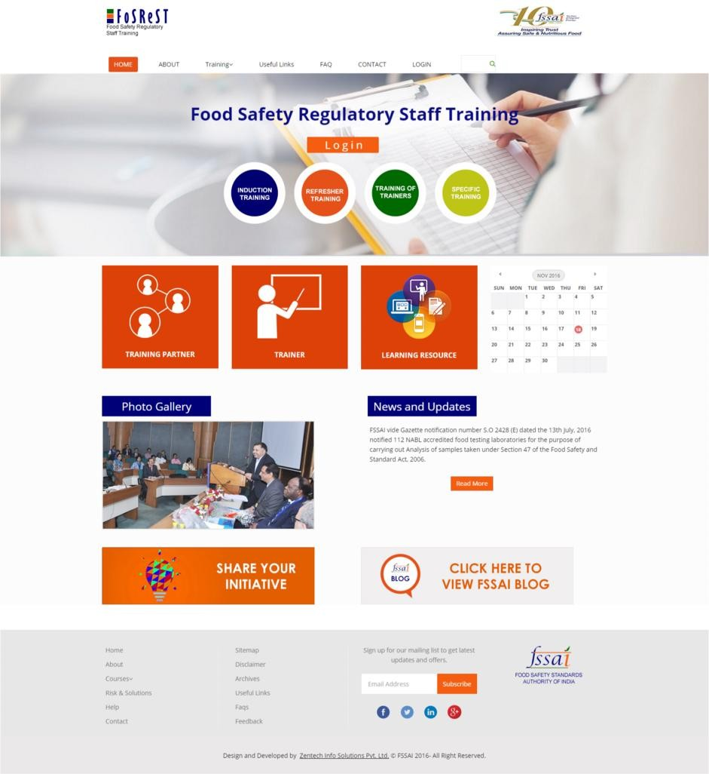

User can view photos of events, trainings etc, uploaded on the portal

User can view latest news

& updates related to trainings

User can share there initiative with FSSAI

User can view blogs written by different experts

**Notes: -** State Admin will create login ids of new employees/ old employees.

State Admin will nominate their employees for different trainings as per their need.

State admin can choose their required training date and trainers from the pool of trainers.

Training Institutes will conduct the training as requested by state admin.

FSSAI admin will manage this portal and address queries raised by any stakeholders on the working &

management.

1. State Admin will create Login Ids of eligible officers.

2. User will click here to attend online foundation phase.

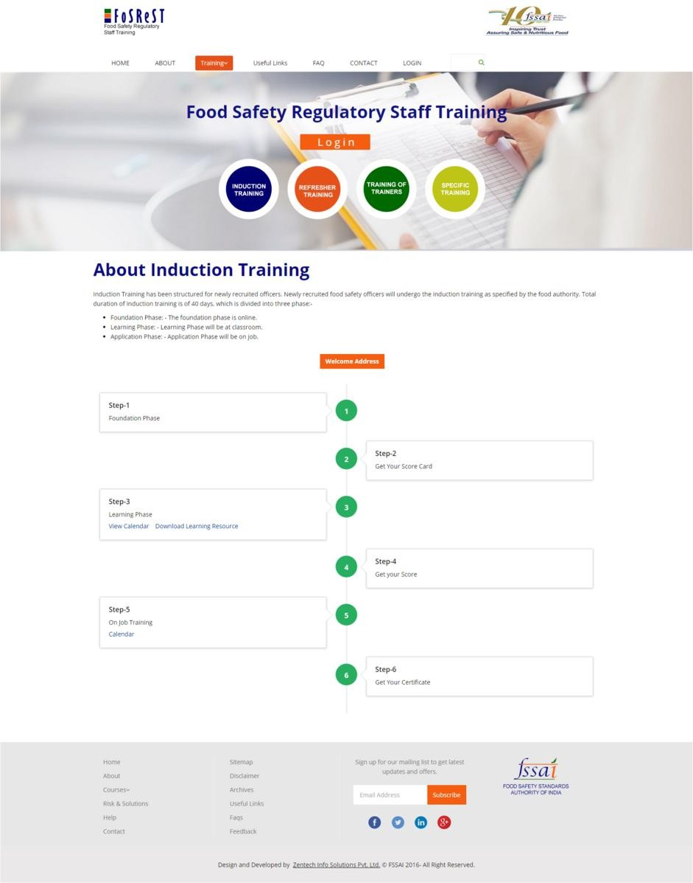

Assessment score of Foundation Phase will be displayed here

State Admin will nominate eligible officers for classroom training

1. State Admin will upload on job training calendar.

Assessment score of Learning Phase will be displayed here

2. User will upload his/her

report of “On Job’ training On successful completion,

certificate can be

downloaded from here